Test Case: tc001_SPX_Dev5_Crear_Solicitud_Articulo_Almacen
Step 1 - Enter username and password and click to button Enter : Credentials Entered
Image file-name: QC_Testing-tc001_SPX_Dev5_Crear_Solicitud_Articulo_Almacen-1787869645832

Step 2 - Select to UEN and Access to Request for a New Inventory Item : UEN Correctly selected and Correct access
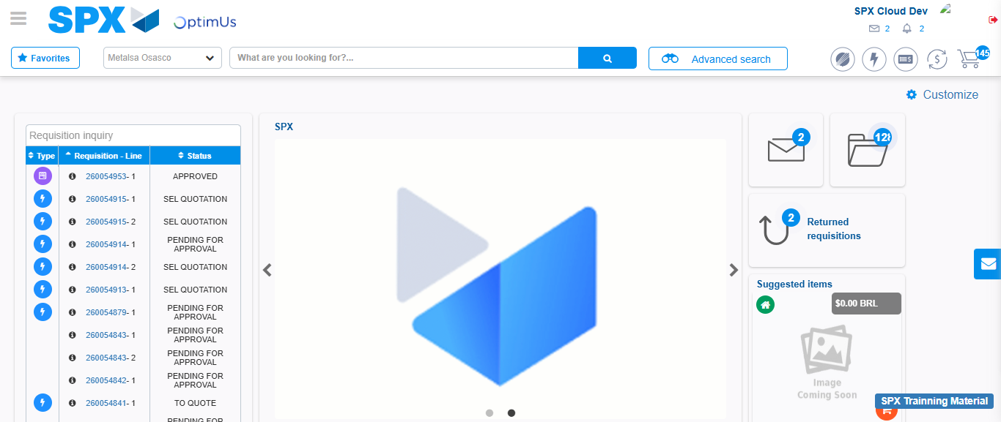Image file-name: QC_Testing-tc001_SPX_Dev5_Crear_Solicitud_Articulo_Almacen-1787869671223

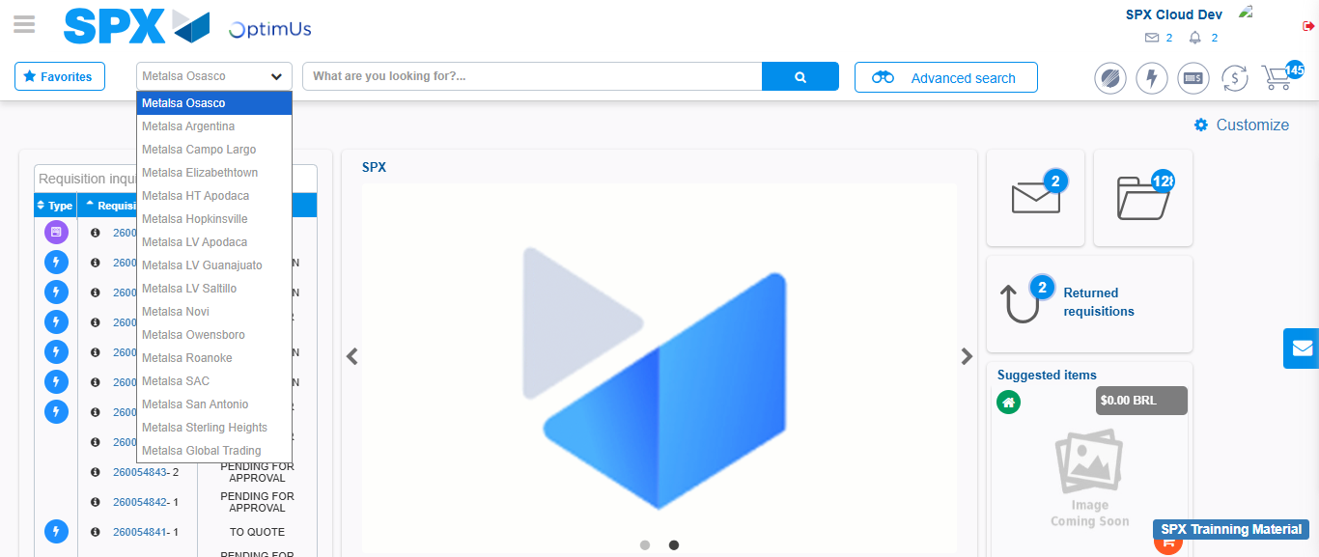Image file-name: QC_Testing-tc001_SPX_Dev5_Crear_Solicitud_Articulo_Almacen-1787869671845

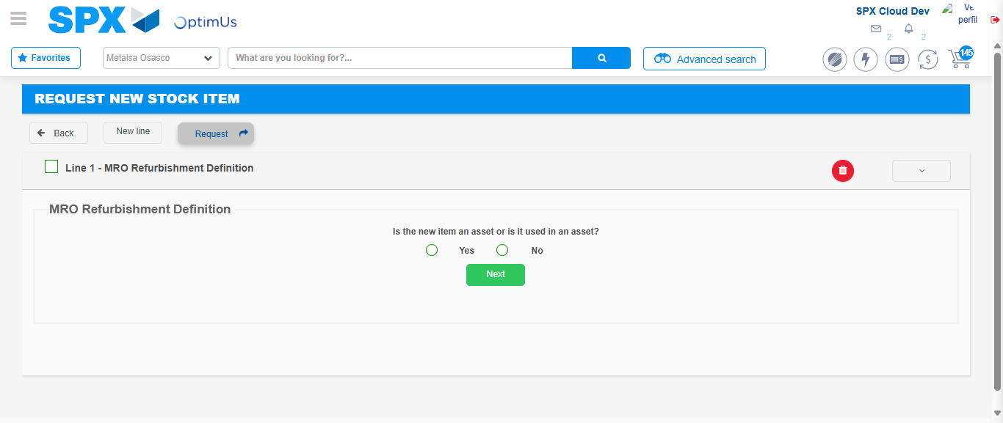Image file-name: QC_Testing-tc001_SPX_Dev5_Crear_Solicitud_Articulo_Almacen-1787869716554

Step 3 - Select options first section : Options seleted correctly
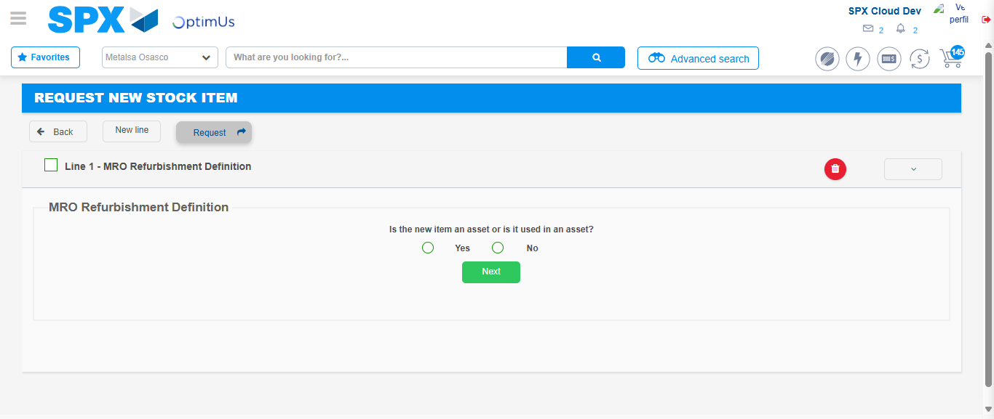Image file-name: QC_Testing-tc001_SPX_Dev5_Crear_Solicitud_Articulo_Almacen-1787869716847

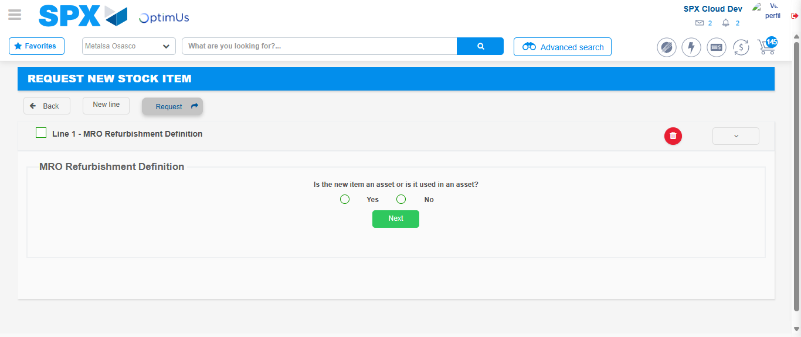Image file-name: QC_Testing-tc001_SPX_Dev5_Crear_Solicitud_Articulo_Almacen-1787869717060

Step 4 - Select options at Screen: Options seleted correctly
Image file-name: QC_Testing-tc001_SPX_Dev5_Crear_Solicitud_Articulo_Almacen-1787869716847

Image file-name: QC_Testing-tc001_SPX_Dev5_Crear_Solicitud_Articulo_Almacen-1787869717060

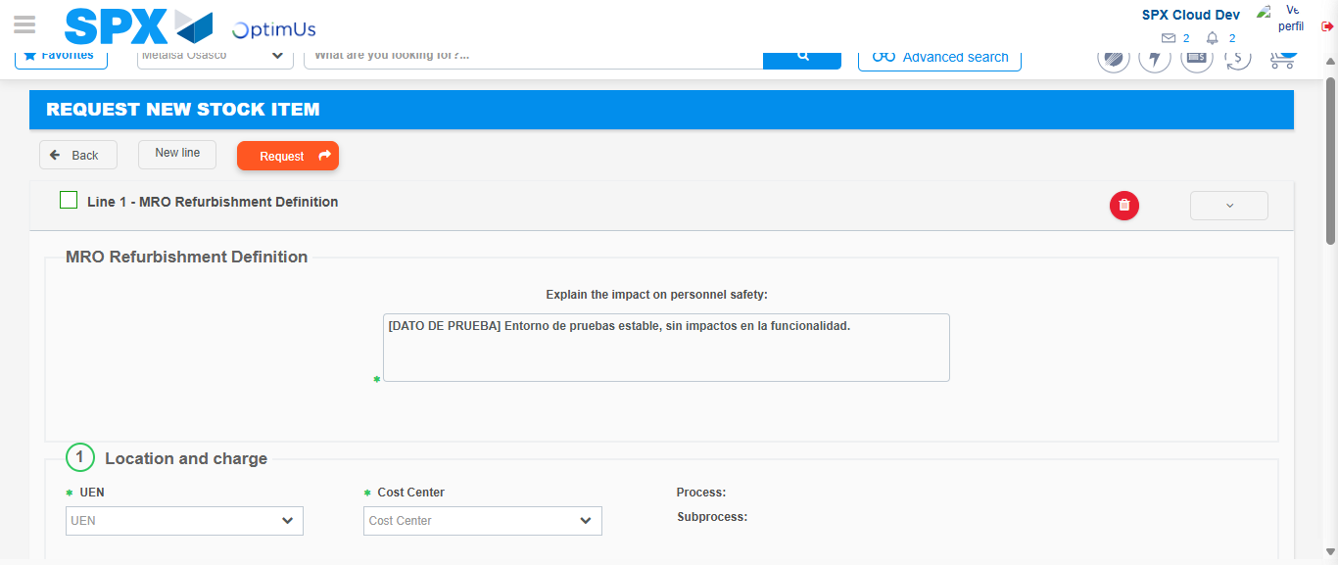Image file-name: QC_Testing-tc001_SPX_Dev5_Crear_Solicitud_Articulo_Almacen-1787869723059

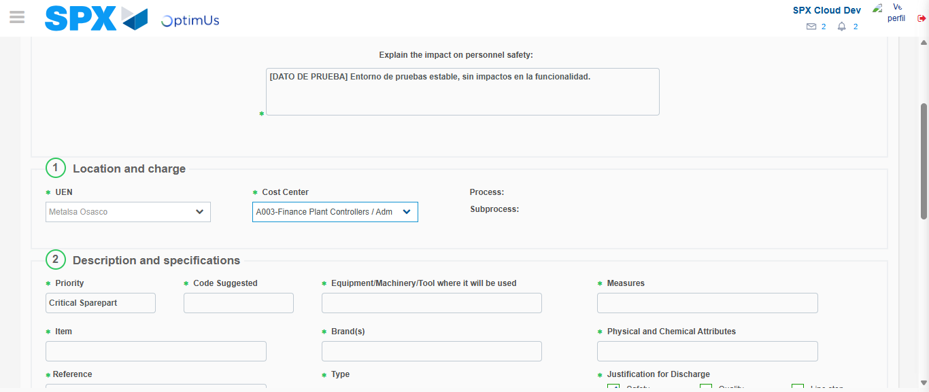Image file-name: QC_Testing-tc001_SPX_Dev5_Crear_Solicitud_Articulo_Almacen-1787869725579

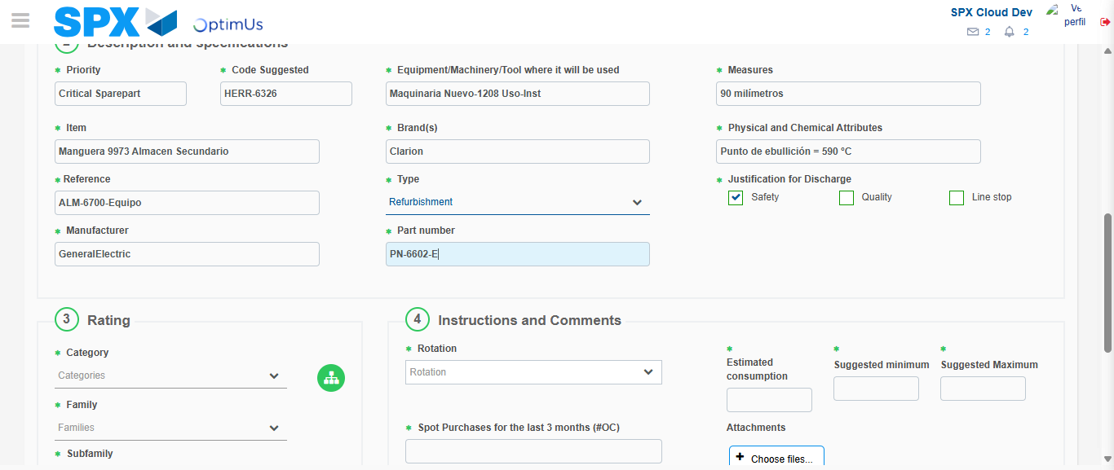Image file-name: QC_Testing-tc001_SPX_Dev5_Crear_Solicitud_Articulo_Almacen-1787869727064

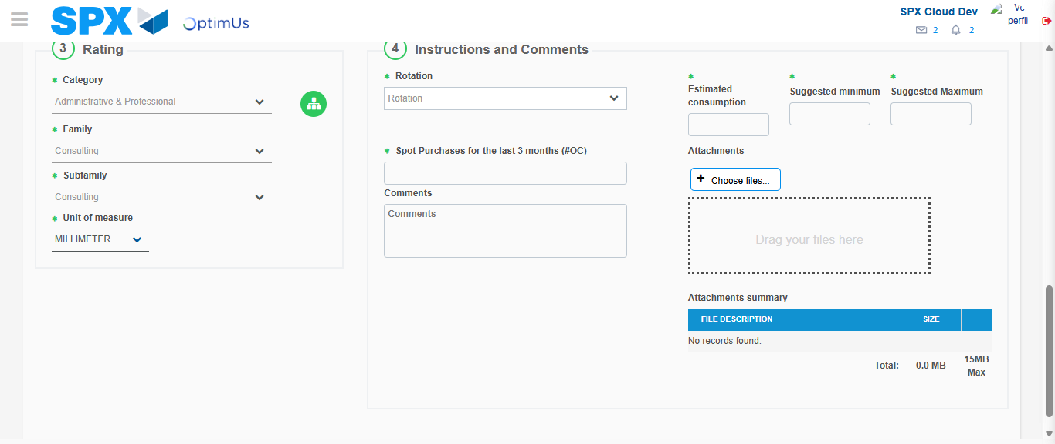Image file-name: QC_Testing-tc001_SPX_Dev5_Crear_Solicitud_Articulo_Almacen-1787869730432

Step 5 - Request New Item : Request Accepted
Image file-name: QC_Testing-tc001_SPX_Dev5_Crear_Solicitud_Articulo_Almacen-1787869671223

Image file-name: QC_Testing-tc001_SPX_Dev5_Crear_Solicitud_Articulo_Almacen-1787869671845

Image file-name: QC_Testing-tc001_SPX_Dev5_Crear_Solicitud_Articulo_Almacen-1787869716554

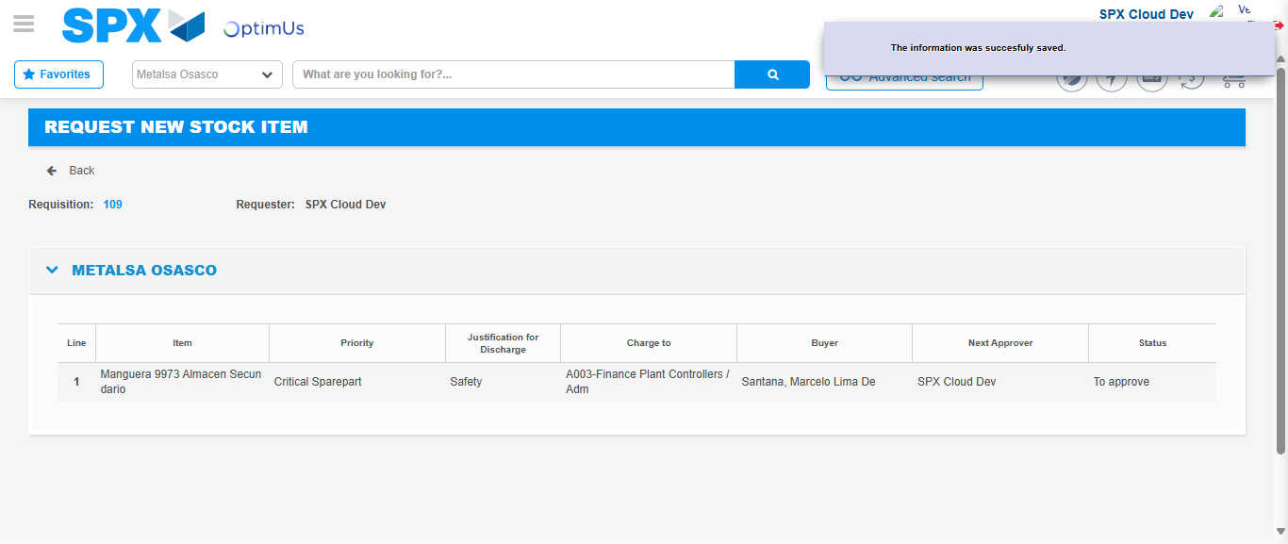Image file-name: QC_Testing-tc001_SPX_Dev5_Crear_Solicitud_Articulo_Almacen-1787869737125

Image file-name: QC_Testing-tc001_SPX_Dev5_Crear_Solicitud_Articulo_Almacen-1787869737294

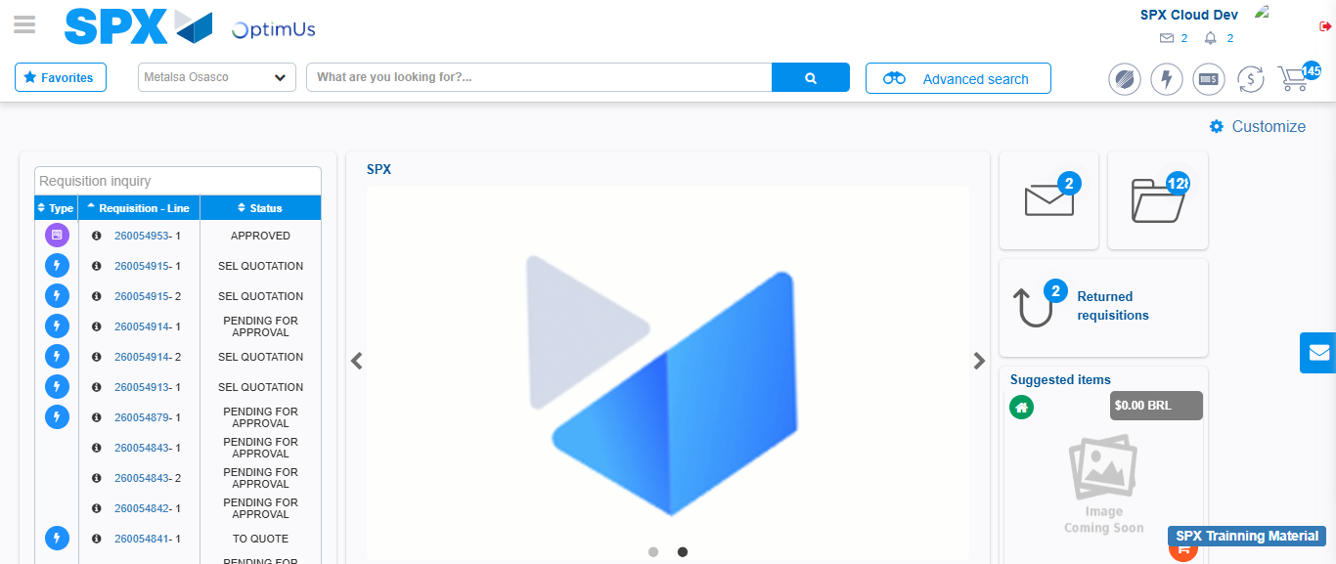Image file-name: QC_Testing-tc001_SPX_Dev5_Crear_Solicitud_Articulo_Almacen-1787869758479

Step 7 - Return to Main Page SPX : Return to Main Page SPX
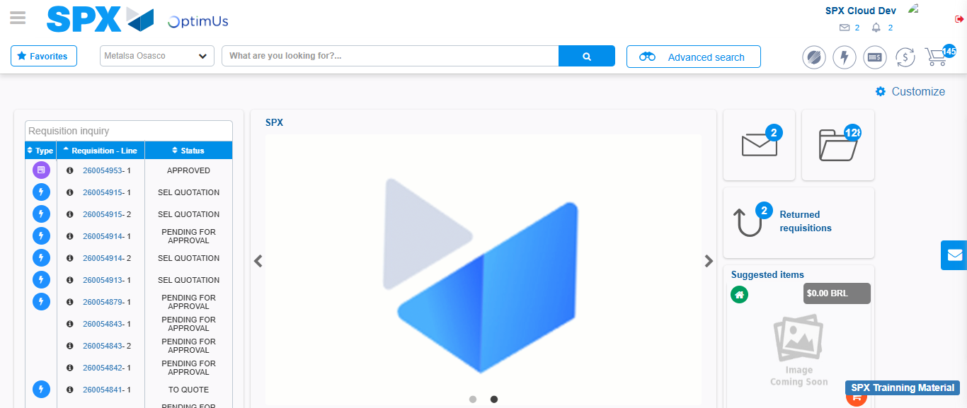Image file-name: QC_Testing-tc001_SPX_Dev5_Crear_Solicitud_Articulo_Almacen-1787869758784

